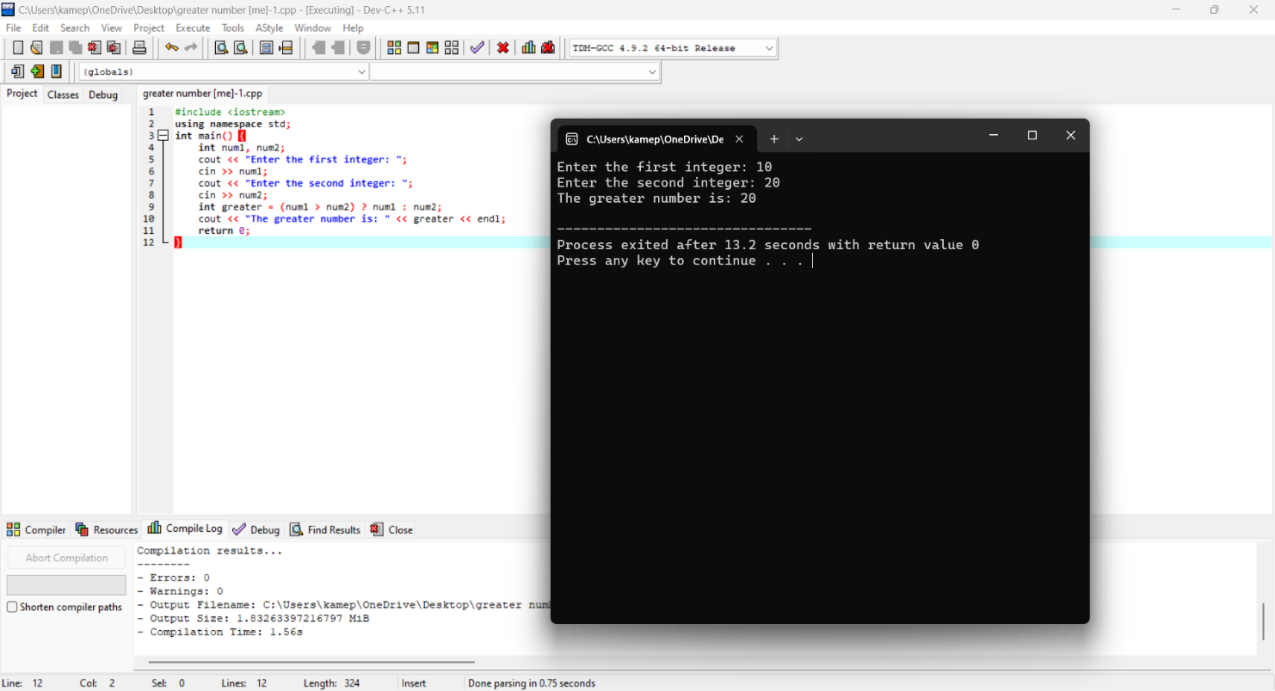1)Greater number

2) PERFECT NUMBER OR NOT

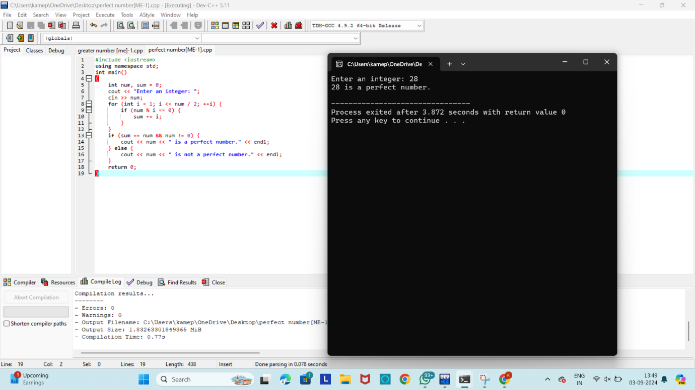

3)PRIME OR NOT

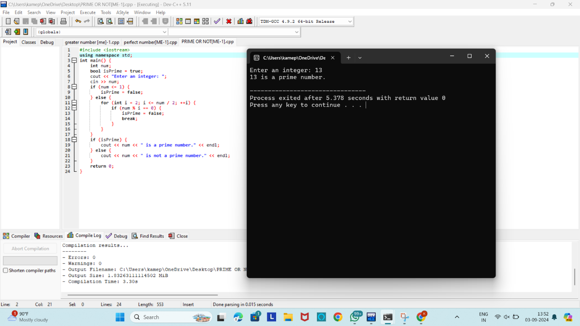

4)AREA OF SPHERE,CYLINDER

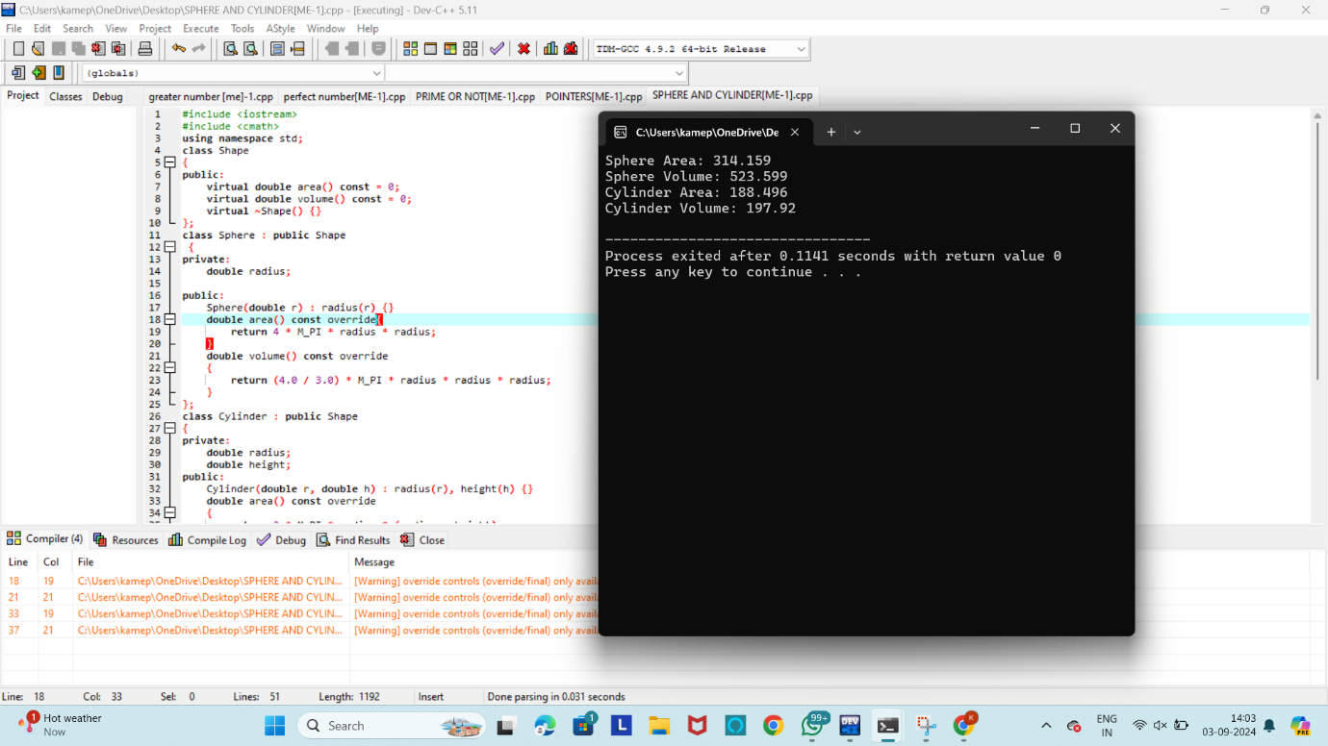

5)AREA OF SQUARE,RECTANGLE,CIRCLE

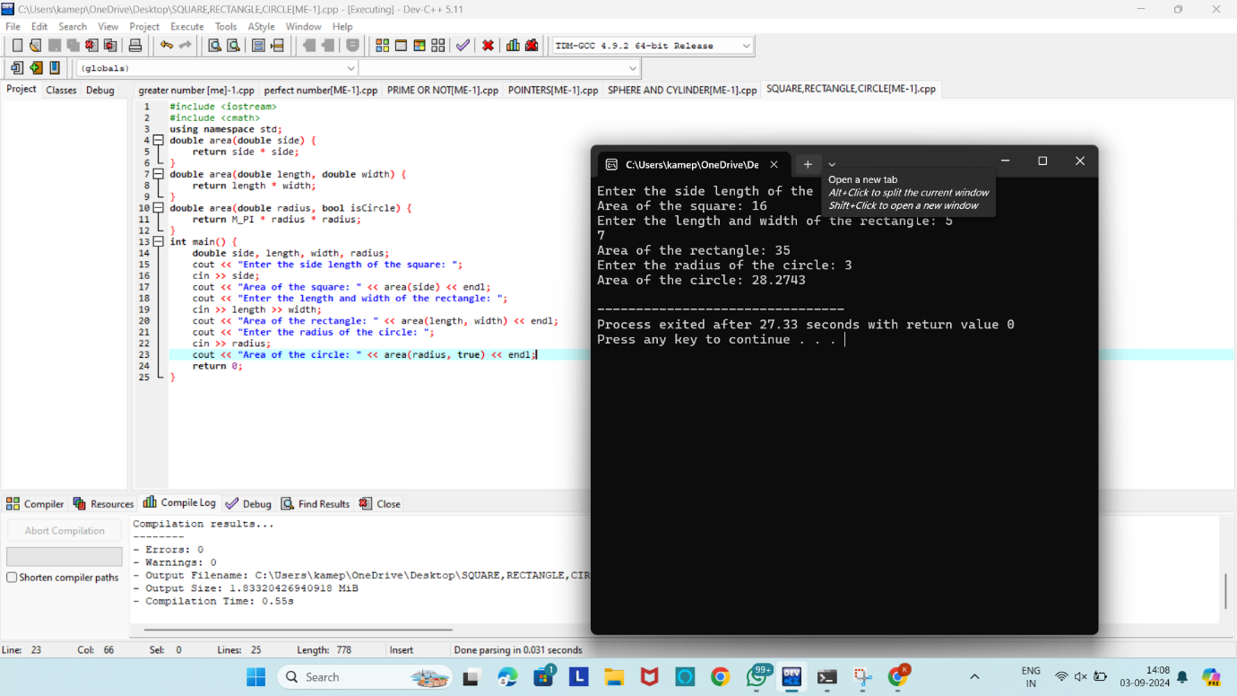

6) TWO-DIMENSIONAL ARRAY USING POINTERS

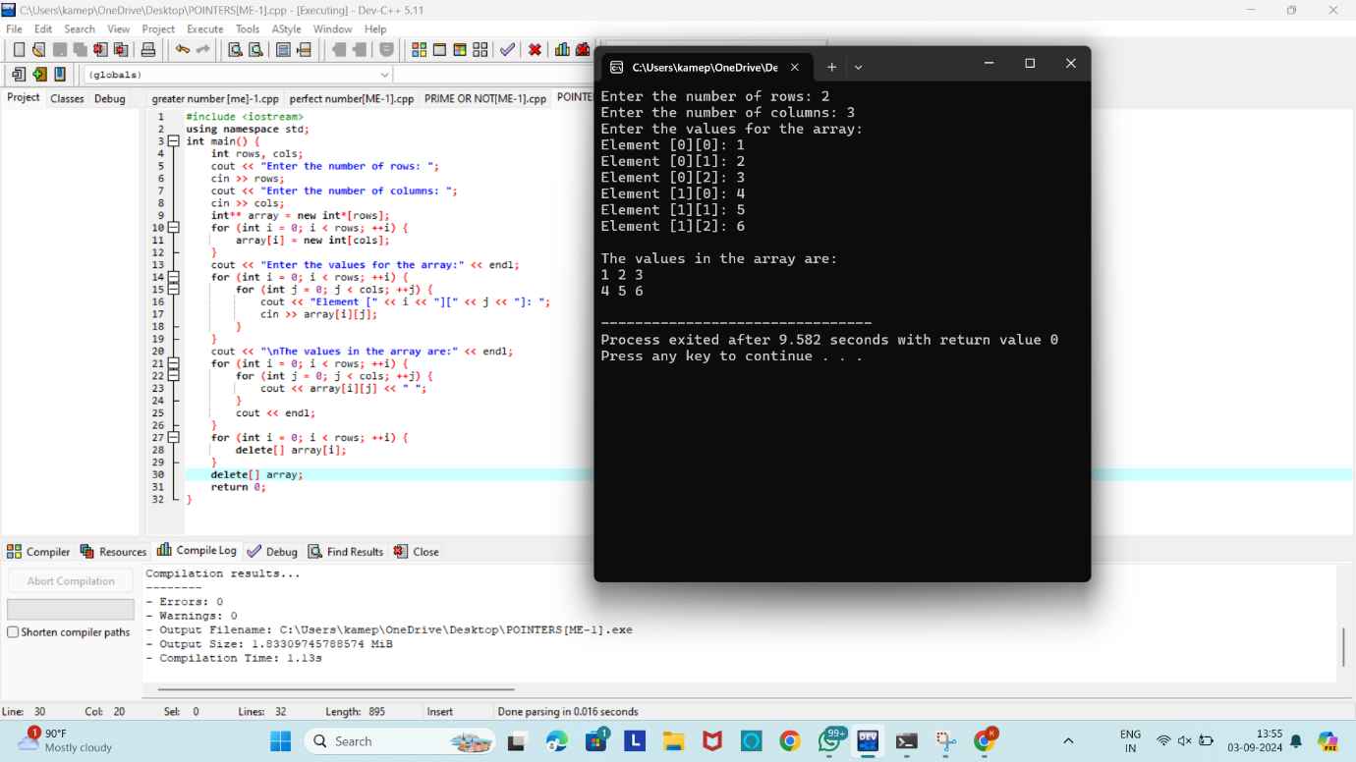

7) CONSTRUCTOR AND DESRTUCTOR

